**TOPICS: Allowed Time:** 120 Minutes

**Instructions: Total Marks:** 40

1. Gossips are not allowed.
2. Teacher assistants are for your help, so be nice with them. Respect them as they are teaching you. Raise your hands if you have some problem and need help from TA. Avoid calling them by raising your voice and disturbing the environment of Lab.
3. TA may deduct your marks for any kind of ill-discipline or misconduct from your side.
4. Evaluation will be considered final and you cannot debate for the marks. So, focus on performing the tasks when the time is given to you.
5. Paste the query as well as result table screenshot as a result of each task

**Task 01: _________________________ ___________ (15 Marks)**

Create a database named **ATM_USERS_DB** according to this schema



|  |  |  |
| --- | --- | --- |
| Table Name: **User** | | |
| **Col Name** | **Data Type** | **constraints** |
| UserID | Int | Primary Key |
| Name | VARCHAR(20) | Not Null |
| PhoneNum | VARCHAR(15) | Not Null |
| City | VARCHAR(20) | Not Null |

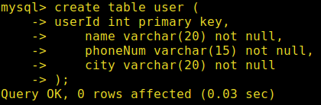

|  |  |  |
| --- | --- | --- |
| Table Name: **CardType** | | |
| **Col Name** | **Data Type** | **constraints** |
| CardTypeID | Int | Primary Key |
| Name | VARCHAR(15) |  |
| Description | VARCHAR(40) | Not Null |

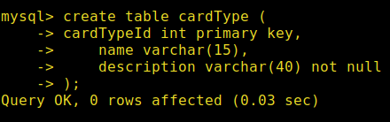

|  |  |  |
| --- | --- | --- |
| Table Name: **Card** | | |
| **Col Name** | **Data Type** | **constraints** |
| CardNum | VARCHAR(20) | Primary key |
| CardTypeID | Int | Foreign Key referencing CardType(CardTypeID) |
| PIN | VARCHAR(4) | Not Null |
| ExpireDate | DATE | Not Null |
| Balance | Float | Not Null |

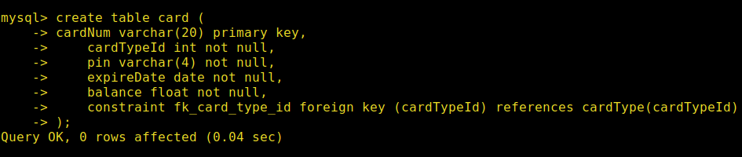

|  |  |  |
| --- | --- | --- |
| Table Name: **UserCard** | | |
| **Col Name** | **Data Type** | **constraints** |
| UserID | Int | Foreign key referencing User(UserID) |
| CardNum | VARCHAR(20) | Foreign Key referencing Card(CardNum), Primary key |

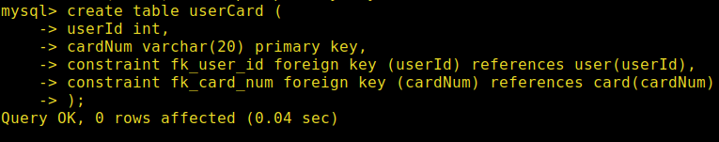

|  |  |  |
| --- | --- | --- |
| Table Name: **Transaction** | | |
| **Col Name** | **Data Type** | **constraints** |
| TransID | Int | Auto_Increment, Primary Key |
| TransDate  amount | DATE  Int | Not Null  Not null |
| CardNum | VARCHAR(20) | Foreign Key referencing Card(CardNum) |

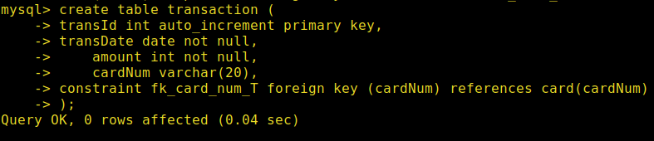

Insert records into the tables with the following data:

**USER:**

|  |  |  |  |
| --- | --- | --- | --- |
| **UserID** | **Name** | **PhoneNum** | **City** |
| 1 | Ali | 03036067000 | Narowal |
| 2 | Ahmad | 03036047000 | Lahore |
| 3 | Aqeel | 03036063000 | Karachi |
| 4 | Usman | 03036062000 | Sialkot |
| 5 | Hafeez | 03036061000 | Lahore |

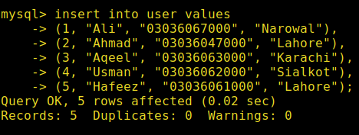

**CardType:**

|  |  |  |
| --- | --- | --- |
| **CardTypeID** | **Name** | **Description** |
| 1 | Debit | Spend Now, Pay Now |
| 2 | Credit | Spend Now, Pay Later |

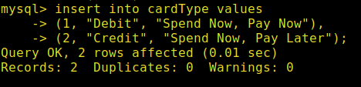

**Card:**

|  |  |  |  |  |
| --- | --- | --- | --- | --- |
| **CardNum** | **CardTypeID** | **PIN** | **ExpireDate** | **Balance** |
| 1234 | 1 | 1770 | 2022-07-01 | 43025.31 |
| 1235 | 1 | 9234 | 2020-03-02 | 14425.62 |
| 1236 | 1 | 1234 | 2019-02-06 | 34325.52 |
| 1237 | 2 | 1200 | 2021-02-05 | 24325.30 |
| 1238 | 2 | 9004 | 2020-09-02 | 34025.12 |

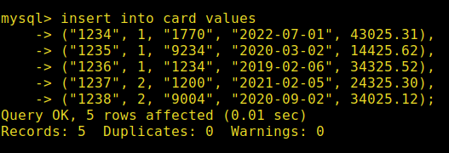

**UserCard:**

|  |  |
| --- | --- |
| **UserID** | **CardNum** |
| 1 | 1234 |
| 1 | 1235 |
| 2 | 1236 |
| 3 | 1238 |
| 4 | 1237 |

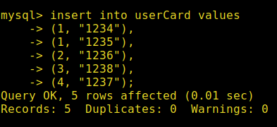

**Transaction:**

|  |  |  |
| --- | --- | --- |
| **TransDate** | **CardNum** | **Amount** |
| 2017-02-02 | 1234 | 500 |
| 2018-02-03 | 1235 | 3000 |
| 2020-01-06 | 1236 | 2500 |
| 2016-09-09 | 1238 | 2000 |
| 2020-02-10 | 1234 | 6000 |

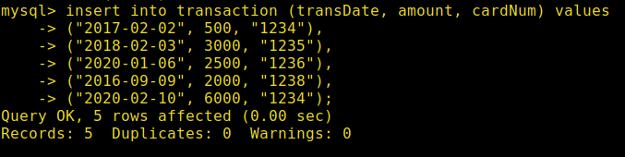

**Task 02: _________________________ ___________ (06 Marks)**

1. Show the details of users along with their card numbers and card type (only for users who have cards).

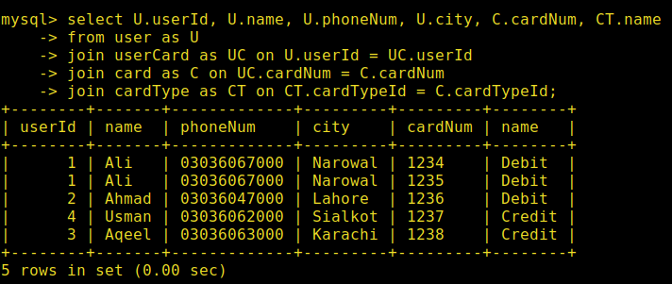

1. Show all cards and their owners, if they exist (include cards even if they don’t belong to any user).

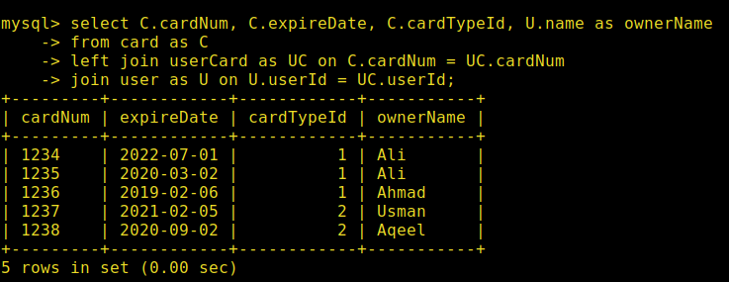

1. Show users and their card details where the card has expired.(expire date < CURRENT_DATE)

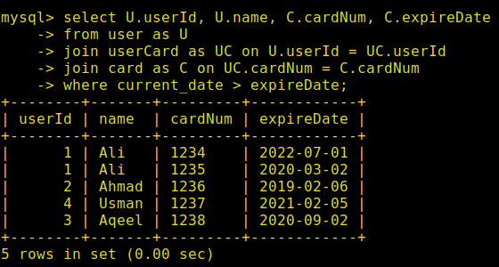

1. Show transaction details for cards of type "Credit".

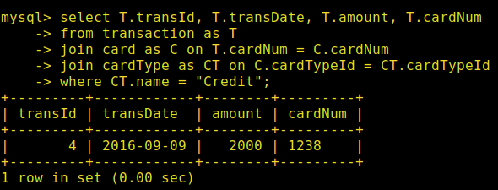

1. Write a query to display the user ID, name, city, card type, card expiration date, and balance for users who have cards expiring after January 1, 2020.

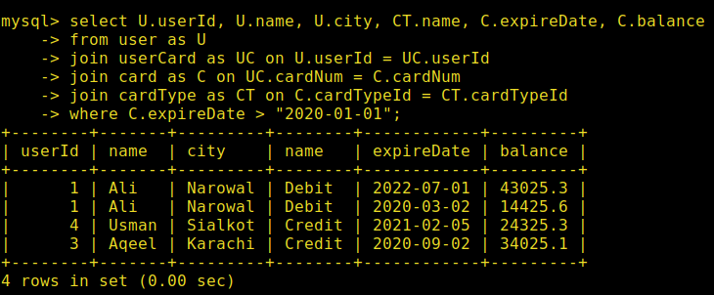

1. Display all the details of Emp who is not assigned to any department.

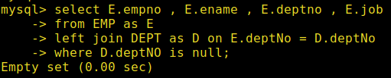

**Task 03: _________________________ ___________ (10 Marks)**

1. Retrieve the details of the users who do not own any card.

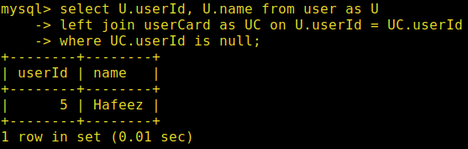

1. Show those card pairs which are expiring in the same year.

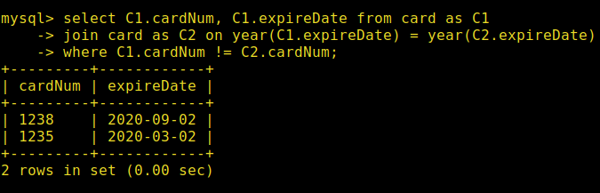

1. Show those user pairs whose names’ first characters are the same.

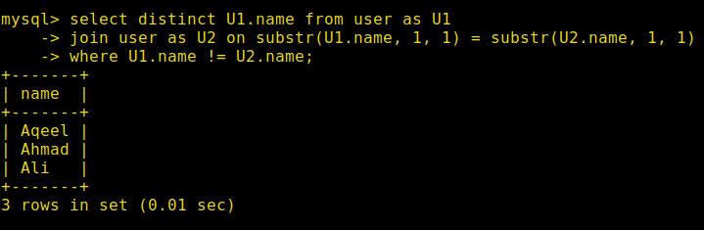

1. Find the cards that have no transactions associated with them. Display the card number and card owner’s name.

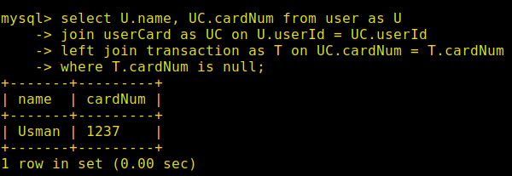

**Note:**

**Update the database using this query before moving ahead**

**UPDATE User SET city = 'Lahore' WHERE userId = 2;**

**UPDATE Card SET cardTypeID = 2, balance = 15000 WHERE cardNum = '1236';**

**UPDATE `Transaction` SET amount = 3000 WHERE cardNum = '1236';**

1. Write a query to display the user name, card number, card type, transaction date, transaction amount, and card balance for all users who:

* Live in "Lahore",
* Have a card of type "Credit",
* Have made transactions greater than 2000,
* And whose card balance is greater than 10,000.

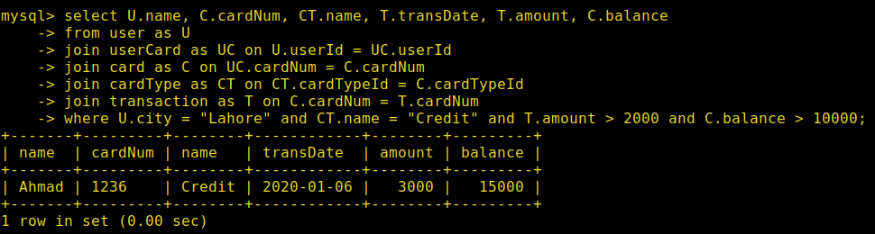

**Task 04: _________________________ ___________ (09 Marks)**

1. Find all users who have both a debit card and a credit card.

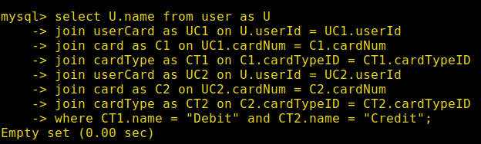

1. List users who have made transactions on cards that will expire within the next 30 days.

**Note: you can use Date_Add(Current_Date , Interval 30 Day) to add 30 days**

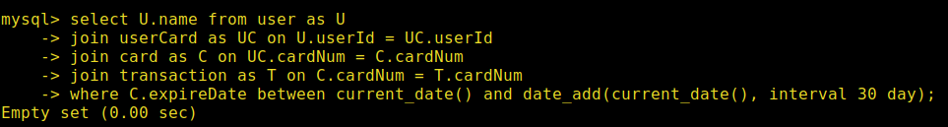

1. find cards that share the same balance but are owned by different users.

